

Checks status of your cluster

During cluster formation:

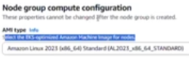 ……golden AMi capable of cluster

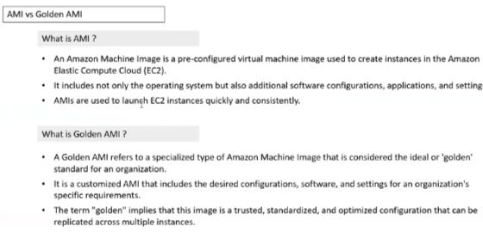

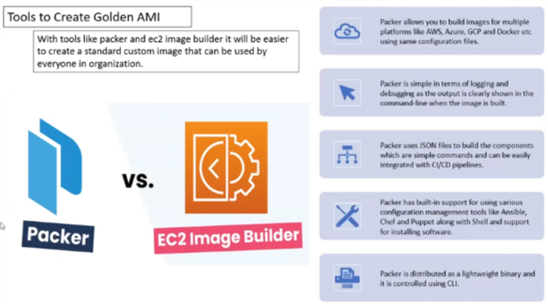

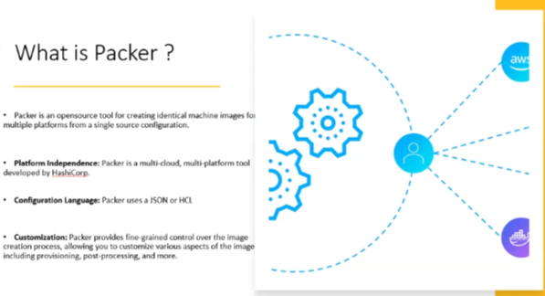

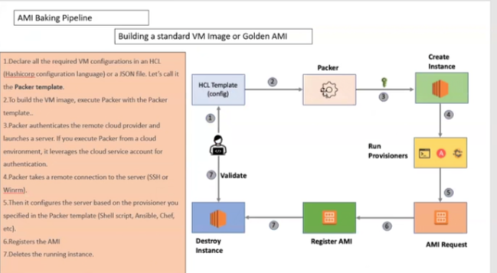

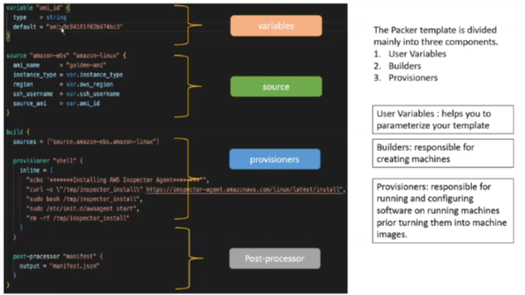

>> Smoke testing in K8S in chatgpt ……cluster test

Steps to upgrade K8S cluster

1. Control-plane

Check if any POD is having single ReplicaSet, if yes, make the replicaset to R2

Kubent install on linux and run in chatgpt

Upgrade control plane in chatgpt, UPGRADE the cluster to 1.33 as per chatgpt



Gives you optimized AMI for 1.33. Use the AMI and get details from AWS. In industry, this AMI can be used or the AMI that we created earlier in jumhost can be used, but it is not used. In industry, the AMI is created via pipeline as an input, make installations to the server of the imputed AMI, then create AMI and make use of this AMI to create/upgrade a cluster

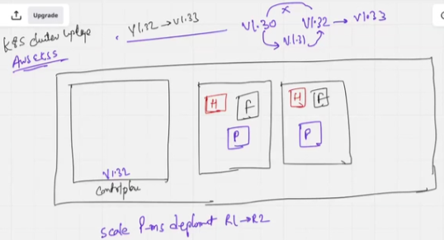

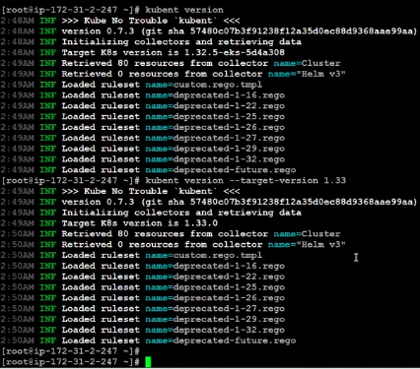 

1. Worker-node

Goto worker node >> ASG >> AMI >> update launch template (id) with 1.33 ami in chatgpt

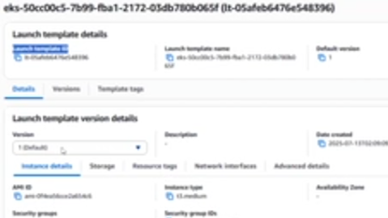

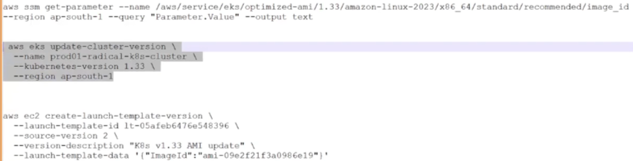

After upgrade

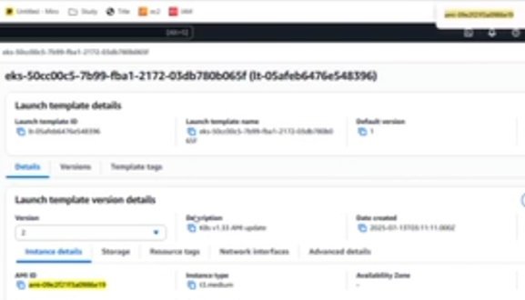

Understanding upgrade background

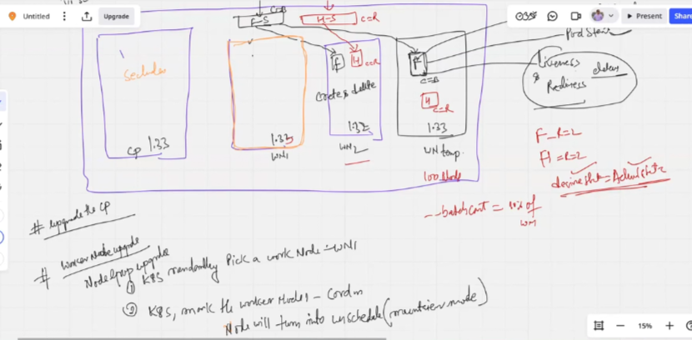

Above image explains to us how Cordon and Drain works in pod eviction process during upgrade as per below upgrade steps

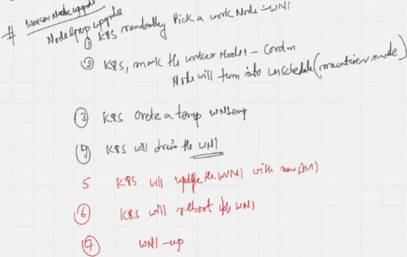

Steps to work with multibranch pipeline using cloudcortex S

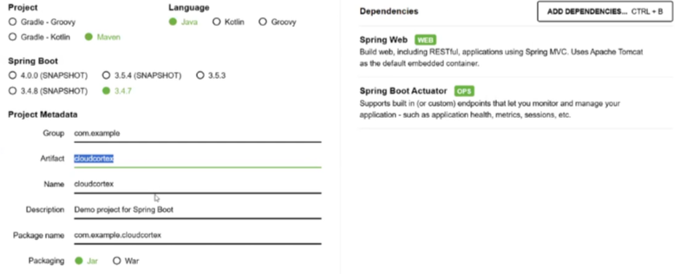

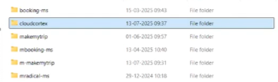

Goto IntelliJ >> Open project from existing source >> Maven. >> cloudcortex

Right click project >> New file >> Jenkinsfile, Dockerfile >> Update dockerfile from makemytrip project, Update Jenkinsfile from github repo 

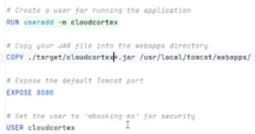 ……update makemytrip to cloudcortex

Right click project >> New directory >> kubernetes >> New directory >> dev, prod, preprod

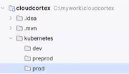

Goto ECR >> create repository >> cloudcortex >> Create

**It has to be noted that, nexus, sonarqube, jenkins-slave is not provided by sir.**

Goto IntelliJ >> Add 00-ingress.yaml, 02-service.yaml, 04-serviceaccount.yaml, 05-deployment.yaml, 06-configmap.yaml, 09-hpa.yaml to dev directory 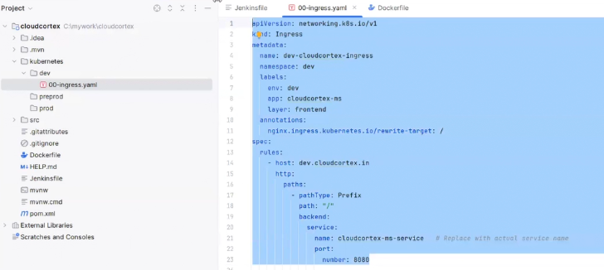

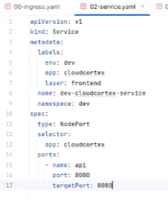 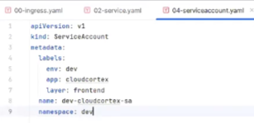

Deployment.yaml is split in 2

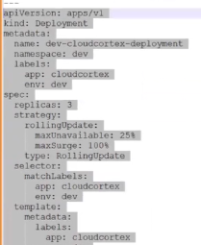

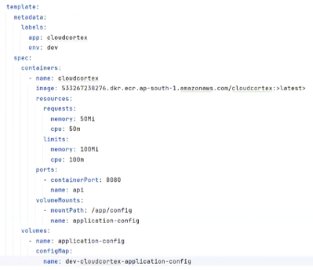

Configmap.yaml has 2 files

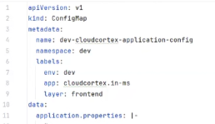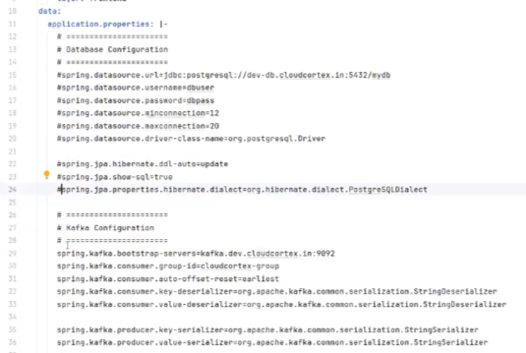

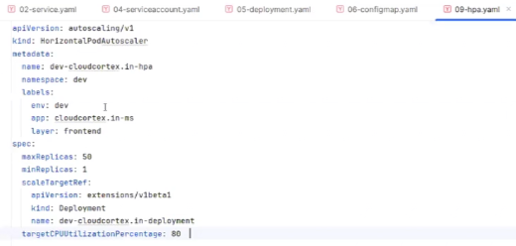

Copy these 6 yaml to preprod and prod

Continue to 19 July